Using DNA to Solve a 1920s Adoption

By Aimee Rose-Haynes
AimeeRoseHaynes.com
facebook.com/AimeeNHaynes
AimeeRoseHaynes@gmail.com

This session explores how DNA testing can be used to solve long-standing genealogical mysteries when traditional research hits a brick wall. Using the case study of a 1920s adoption, we follow the paper trail from misleading documents and false leads to DNA confirmation of the true biological father. Participants will learn the limitations of historical records, the types of DNA testing available, and practical methods for organizing DNA matches to uncover the most recent common ancestor (MRCA). This case highlights how genealogy has evolved, and how DNA provides powerful tools to verify or overturn long-held family stories.

Outline
I. Introduction
- Brief background of the case study
- The “brick wall” question: Who was Richard’s birth father?
II. Paper Records and Their Limitations
- Information from the 1920 pre-adoption birth certificate
- Census discoveries and family records
- Problems with historical documentation:
  - Illegible handwriting or transcription errors
  - Falsified or misrepresented details
  - Informant inaccuracies
III. The False Lead: Jack Rowan
- No evidence of Jack Rowan in records (census, directories, newspapers, Navy listings)
- Importance of verifying multiple sources
IV. Turning to DNA Testing
- When traditional genealogy cannot solve the mystery
- Types of DNA tests: mtDNA, Y-DNA, autosomal
- Who should test first: oldest generation closest to the line
- Cost and database size considerations
V. Working with Autosomal DNA
- Understanding centimorgans (cM) and relationship estimates
- Assigning maternal/paternal labels in Ancestry
- Sorting matches using the Dana Leeds Method
- Identifying DNA networks and the MRCA
VI. Breaking Through the Brick Wall
- Case analysis of Carol (daughter of Richard) and her DNA matches
- Identifying Judy and Jane as key matches
- Tracing the MRCA couple Albert and Susan Neale
- Discovery: William Neale, not Jack Rowan, was the biological father
VII. Lessons Learned
- DNA as a powerful tool to confirm or disprove paper records
- Importance of combining traditional genealogy with modern science
- Remaining questions in the case (Helen’s second child)
VIII. Conclusion
- Case solved through DNA evidence
- Broader implications for genealogy research

Resources to help you on your quest to solve your brick wall:

Newspapers.com | Find a Grave
Been Verified and White Pages | DNAPainter.com
Yearbooks (online or local library) | Local libraries
FamilySearch.org | Emailing local newspaper editors
WikiTree | Google
Genealogy Bank | National Archive
CyndisList.com | Local universities will sometimes have family genealogy books
Banyan DNA | Local county courthouse
Fold3.com | Local genealogy society

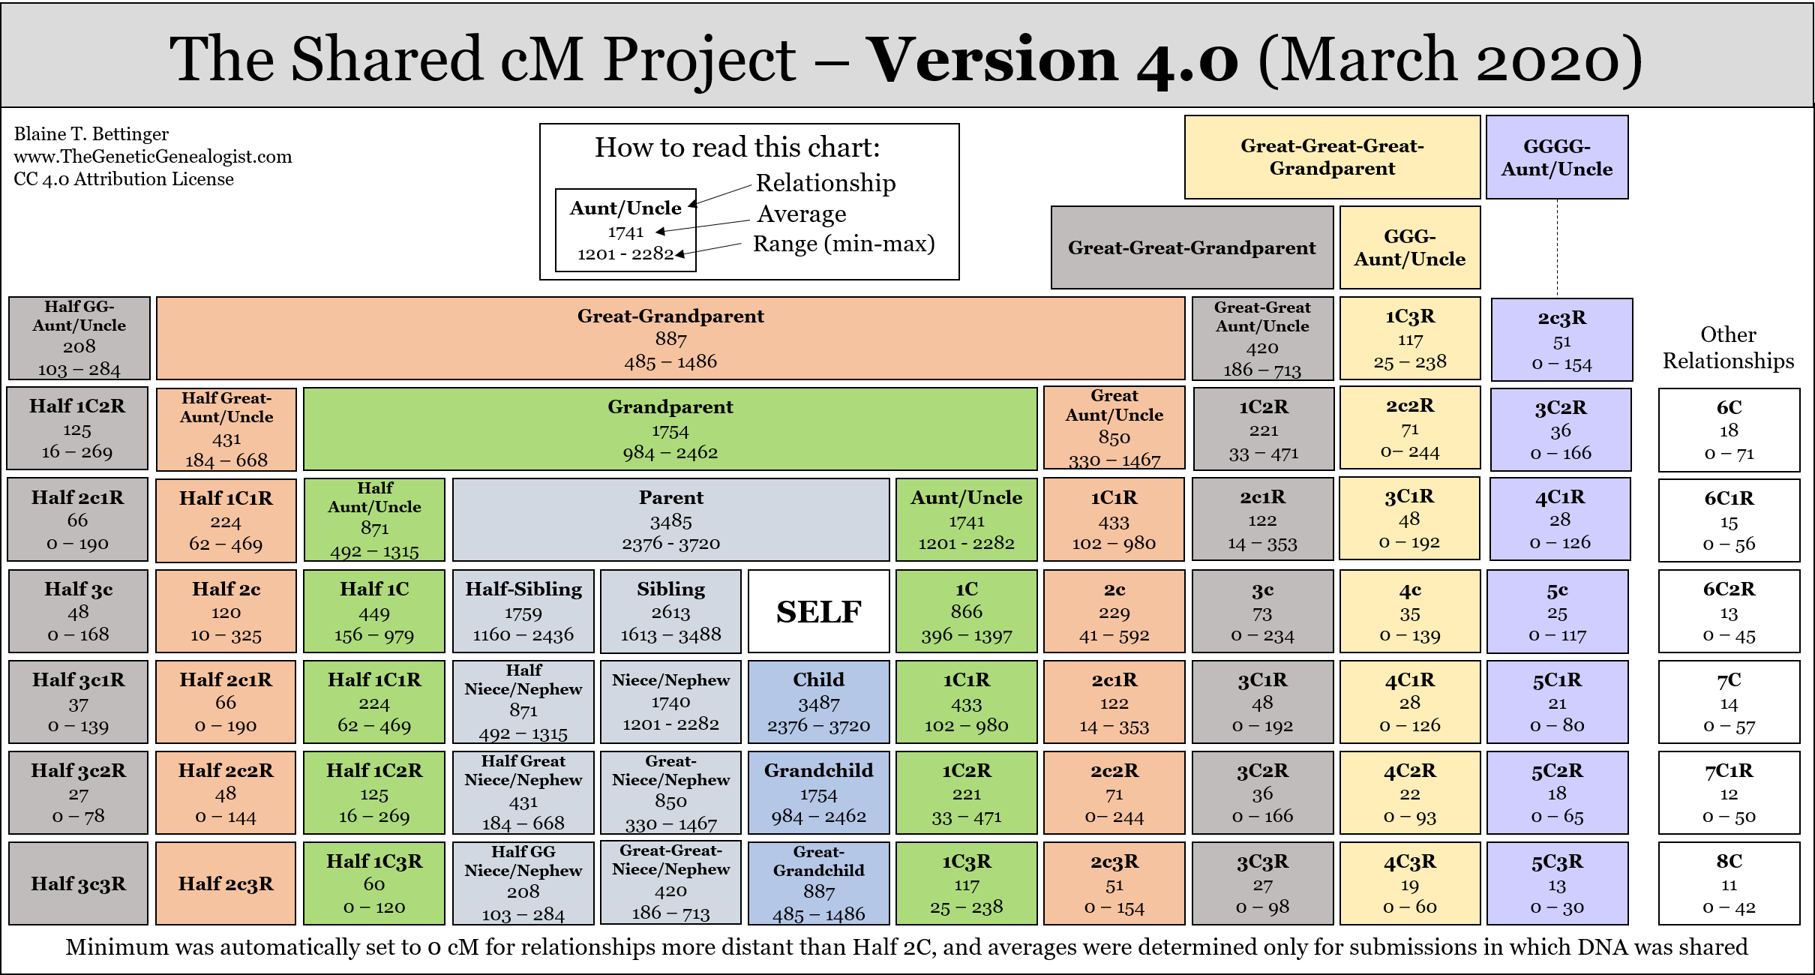
Blaine Bettinger’s Shared cM Project at DNAPainter.com

YDNA-
Y-DNA is inherited directly from father to son and is valuable for tracing paternal ancestry and lineages across many generations. Because it follows the male line, only genetic males are able to take this test. Y-DNA testing is available through Family Tree DNA and is commonly used in genealogical research to confirm or explore paternal connections.
mtDNA-
Mitochondrial DNA (mtDNA) is inherited from mothers by all of their children, both male and female. It is especially useful for tracing maternal ancestry and can reveal information about ancient migration patterns and population history. Since it is passed to every child, anyone can take this test. mtDNA testing is available through Family Tree DNA.
Autosomal DNA-
Autosomal DNA is inherited from both parents and reflects genetic information across the 22 pairs of autosomal chromosomes, covering all branches of the family tree. This type of testing is designed to explore about 6 to 8 generations of ancestry, making it useful for identifying relatives and uncovering broad family connections. Anyone can take an autosomal DNA test. The most common testing companies are Ancestry, 23andMe, MyHeritage, and Family Tree DNA. Ancestry has the largest overall testing database, while MyHeritage offers the largest European testing population.

Recommended Reading
- The Family Tree Guide to DNA Testing and Genetic Genealogy by Blaine T. Bettinger The Family Tree Guide to DNA Testing and Genetic Genealogy: Bettinger, Blaine T.: 9781440300578: Amazon.com: Books

- Guide to DNA Testing: How to Identify Ancestors, Confirm Relationships, and Measure Ethnic Ancestry through DNA Testing by Richard Hill Amazon.com: Guide to DNA Testing: How to Identify Ancestors, Confirm Relationships, and Measure Ethnic Ancestry through DNA Testing eBook : Hill, Richard: Kindle Store

Discover three of my most popular eBooks now available at AimeeRoseHaynes.com

Each guide is designed to help you navigate genealogy with confidence, from mastering DNA tools to uncovering Native ancestry and breaking through tough research brick walls.

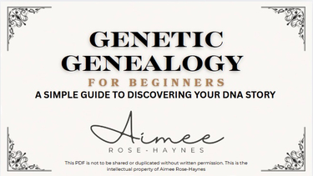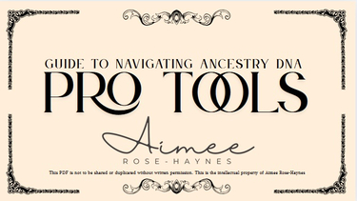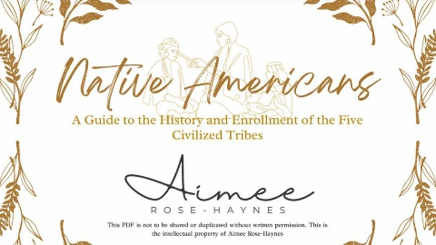
Download your digital copy today!!

